THE ALAN PETERS FURNITURE AWARD 2020 GUIDELINES & ENTRY FORM

Please watch the video called AWARD ENTRY GUIDELINES at https://www.woodomain.com/alanpetersaward

Applications are invited from any woodworker who is a UK resident citizen over 18 who has an enthusiasm and talent for contemporary furniture making to submit up to two original pieces of furniture (hand made, primarily out of wood) that echoes in some way the philosophy of Alan Peters. It will be judged on the following criteria – craftsmanship – originality of design (the idea), aesthetics, use of material and functionality.

How to enter

Follow the instructions below and fill in the attached APPLICATION FORM

- The piece of furniture must be original and designed and made especially and solely by the applicant.
- Submit up to 6 high resolution JPEG images (min 3MB each) for each entry via WeTransfer preferably.
- Return form APP and pay £20 entry fee (per entry – max 2 entries) up until & no later than 30 May 2020.
- Please familiarise yourself with the work of the late Alan Peters OBE. To help you a free 64-page book called Alan Peters – The Makers Maker is available for you to read online.
- The emphasis is on ‘hand’ skill which may include some machining. You can use very limited CNC input.
- Give a statement describing you and your influences, future aspirations and anything you want to tell us about yourself as a woodworker. Max 150 words
- Give a title and description of the piece Max 150 words
- Image captions: give brief numbered descriptions of each shot in the space provided on the entry form.
- Shortlisted pieces (notified around mid-June) must be delivered/collected & insured by applicant.
- Large and heavy items are discouraged. Please email Jeremy Broun (organizer) for guidance if in doubt.

Image requirements

The first stage selection is based on photographs and succinct descriptions. 6 hi resolution images of the completed piece are required (minimum file size 3mb). You may be able to take pictures on your mobile phone. A professional background (eg white) is NOT required. Your images should be well lit and clearly defined including major elevations and close up details of interesting/difficult/innovative features, conveying how it is made. A chair will require a side elevation. It is essential you reference each image strictly: SURNAME/01 etc.Example images:

Thumbnail examples:
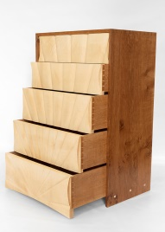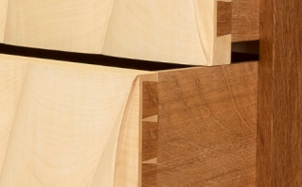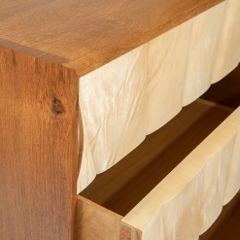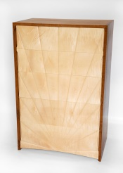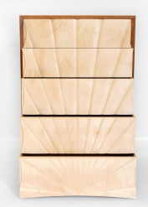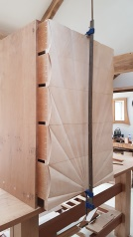

Checklist

Application deadline | Any time up to 30 May 2020
Return APP doc signed to | jb@woodomain.com
Send 6 hires jpeg images to | jb@woodomain.com | Via WeTransfer
Pay entry fee online or bank transfer | Lloyds Bank. Sort code 30.90.54 Acc J K Broun | Acc 00419236
Axminster* delivery & collection | deliver 27 June | 11 or 13 July
Cheltenham* delivery & collection | Deliver (to be confirmed) | Collect to be confirmed
Insurance of item(s) | the applicant’s responsibility
*Axminster Tools & Machinery Nuneaton Store, Bermuda Trade Park, Nuneaton, Warwickshire. CV10 7RA
*The Wilson Art Gallery & Museum, Clarence Street, Cheltenham, GL50 3JT

ENTRY FORM to be emailed to jb@woodomain.com (one form per entry, max 2 entries). Ask someone to help you ‘enable editing’ a Word document.

Please read carefully: Use this form by typing in the required information under the headings provided below

Name
Date of birth
Address
Phone number
Email
Title of piece
Materials
Size: L x W x H
Description | Max 150 words about inspiration, materials & techniques
About me | Max 150 words

Images | Brief descriptive captions.
Surname/01
Surname/02
Surname/03
Surname/04
Surname/05
Surname/06

# One image should show the item in situ of a workshop, being made by applicant.
## entry fee payment options are online by bank transfer or via shopping cart at https://www.woodomain.com/online-store/Alan-Peters-Furniture-Award-2020-ENTRY-FEE-p179739054

I, ………………..……... have read fully and agree to abide by the rules of this award. Please scan your signature and email.

Signed . . . . . . . . . . . . . . . . . . . . . date . . . /. . ./ . .

